**PM4 and IPV4 :**

Subject : Httpd-custom.conf for DMS Server ------🡪 search In outlook

Httpd-custom.conf for PM4 and IT4 service which is already setup.

PM4 and IT4 Service are 2 different applications which uses DMS server perl scripts to create Repositories.

Inorder for external applications to connect to our DMS server you need to do the below settings.

Get the IP address of PM4 or IT4 or any other application and add that to httpd-custom.conf file located at D:\DMS_301\apps\VisualSVN\conf

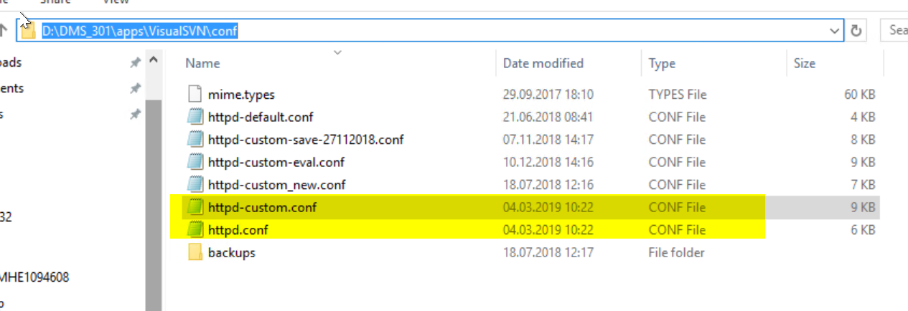

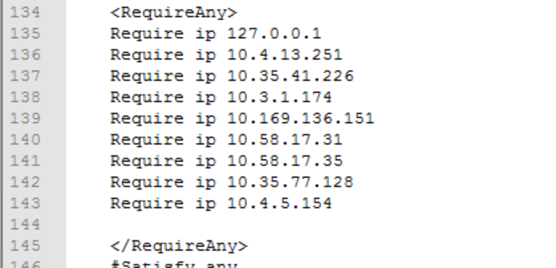

Never Edit httpd.conf file, if any additional setting are required please edit only in httpd-custom.conf

Next thing is ask for service account from that application user and make sure that service account is added to IDM2BCD_ETAS_P_DMS_ADMIN_INTERFACE